SIMATS ENGINEERING

ASSESSMENT TOOL 3

COURSE NAME: Database Management Systems COURSE CODE: CSA05

COURSE OUTCOME COVERED

CO2: Apply the relational model, relational algebra, SQL query structures, and views to solve database querying and data manipulation problems. (BL3, BL6)

Activity Tool : Debugging & Optimisation Task (Low) Assessment Tool Weightage: 30%

Dr. Hemavathi R

QUESTIONS Total Marks: 50
Q.No | Question | Bloom's Level | Marks
1 | Identify and fix the error in the given SQL query that uses incorrect JOIN syntax and returns duplicate results. | BL3 – Apply | 5
2 | The following sub-query returns incorrect results due to a missing correlation. Debug and rewrite it correctly. | BL3 – Apply | 5
3 | A given SQL view definition causes errors when queried. Identify the issue and rewrite a correct and optimized view. | BL3 – Apply | 5
4 | Debug the given relational algebra expression that produces incorrect output for a natural join operation. | BL3 – Apply | 5
5 | The SQL query below violates referential integrity. Identify the violation and modify the statements to enforce proper constraints. | BL3 – Apply | 5
6 | Given an inefficient SQL query with nested loops, rewrite it using JOIN to optimize performance. | BL6 – Create | 5
7 | The GROUP BY query below produces wrong aggregation results. Debug the query and explain the error. | BL3 – Apply | 5
8 | Identify and fix the logical error in a given SQL UPDATE statement that unintentionally modifies all rows in the table. | BL3 – Apply | 5

9 | Optimize the given multi-table SQL query by restructuring sub-queries into JOINs and using appropriate indexes. | BL6 – Create | 5
10 | Debug a given relational calculus expression that returns an empty result set due to incorrect quantifier usage. | BL3 – Apply | 5

Code of Conduct:

I Rohith P (192572013) (Name / Reg No) certify that this submission is my original work and that I have adhered to the guidelines specified for this assessment. I understand that any violation of academic integrity rules will result in disciplinary action.

Signature of the student: Sree B

1.Identify and fix the error in the given SQL query that uses incorrect JOIN syntax and returns duplicate results.

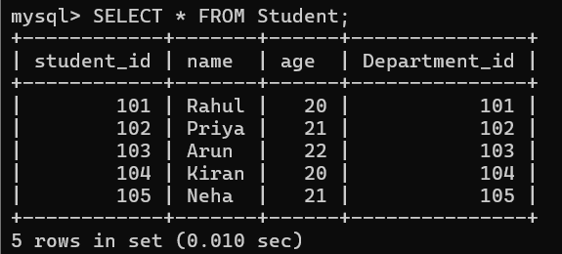

2.The following sub-query returns incorrect results due to a missing correlation. Debug and rewrite it correctly.
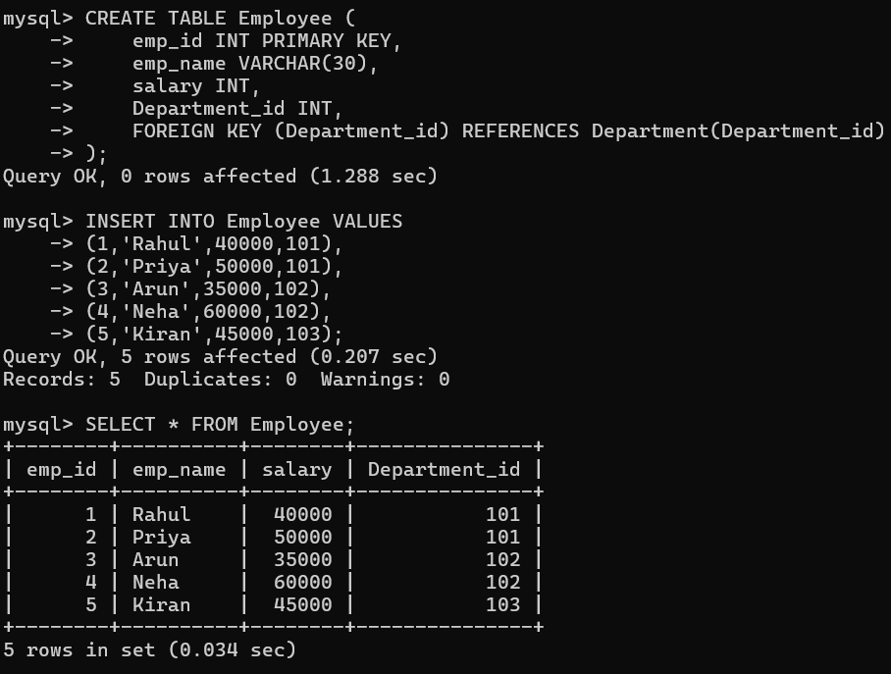

3.A given SQL view definition causes errors when queried. Identify the issue and rewrite a correct and optimized view.

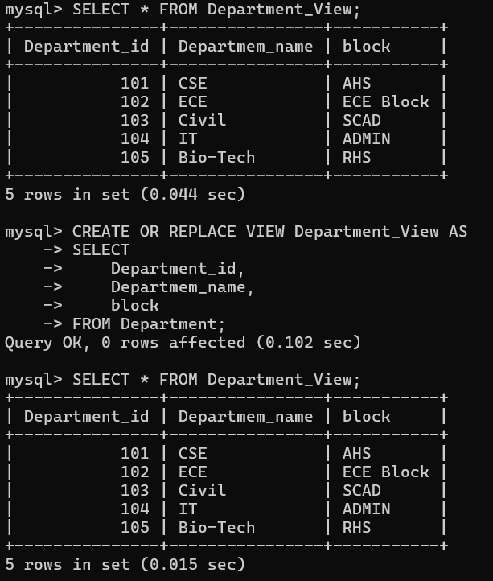

4. Debug the given relational algebra expression that produces incorrect output for a natural join operation.
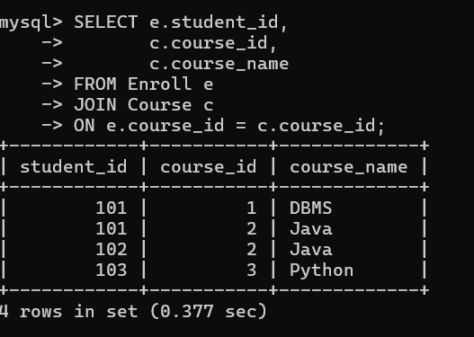

5. The SQL query below violates referential integrity. Identify the violation and modify the statements to enforce proper constraints

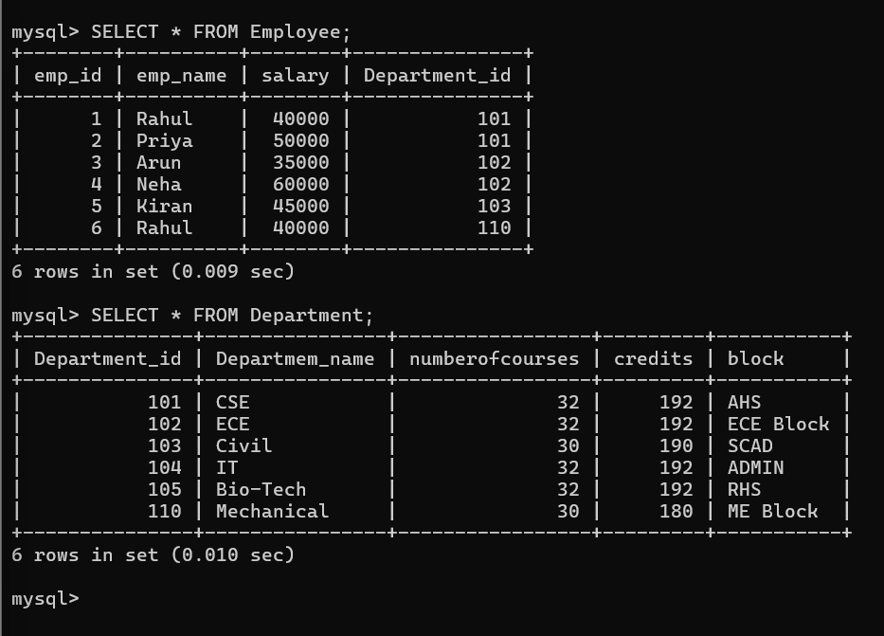

6. Given an inefficient SQL query with nested loops, rewrite it using JOIN to optimize performance

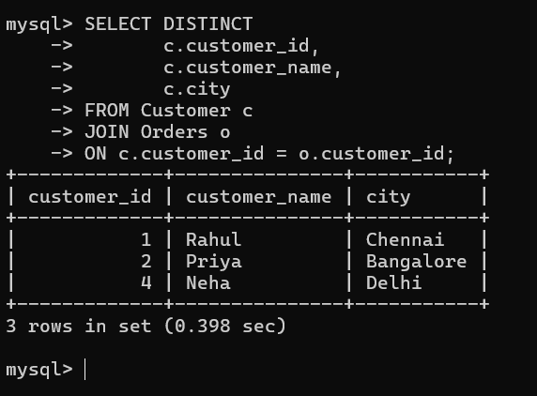

7. The GROUP BY query below produces wrong aggregation results. Debug the query and explain the error.

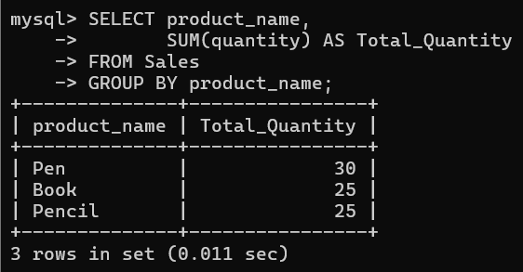

8. Identify and fix the logical error in a given SQL UPDATE statement that unintentionally modifies all rows in the table

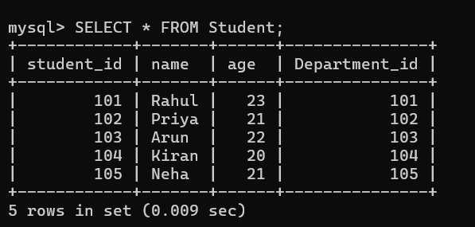

9. Optimize the given multi-table SQL query by restructuring sub-queries into JOINs and using appropriate indexes.

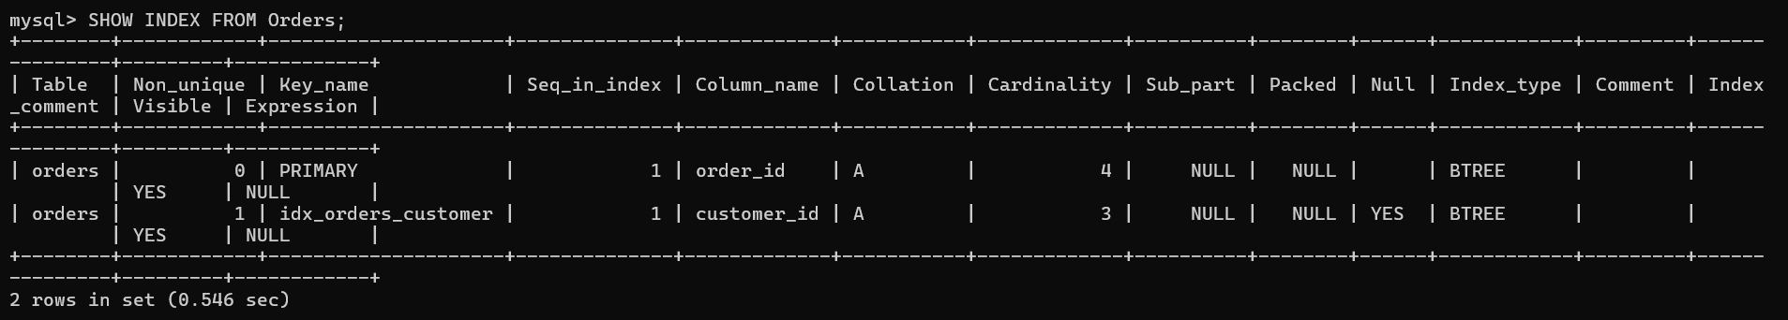

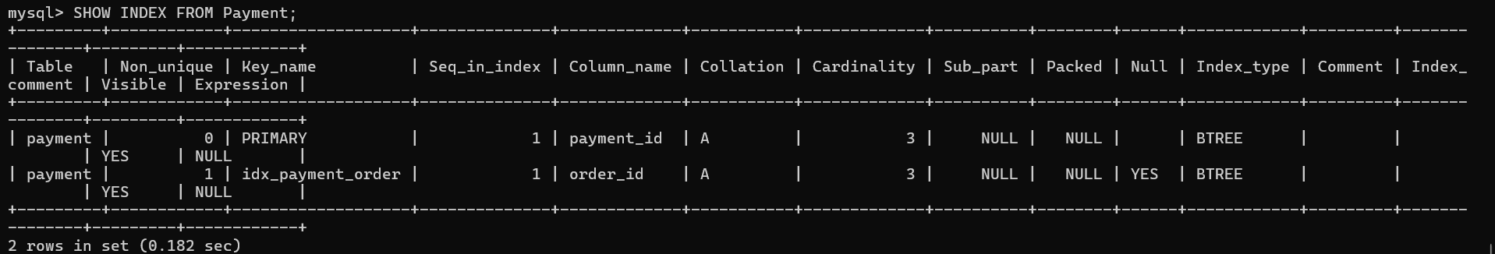

10. Debug a given relational calculus expression that returns an empty result set due to incorrect quantifier usage.

